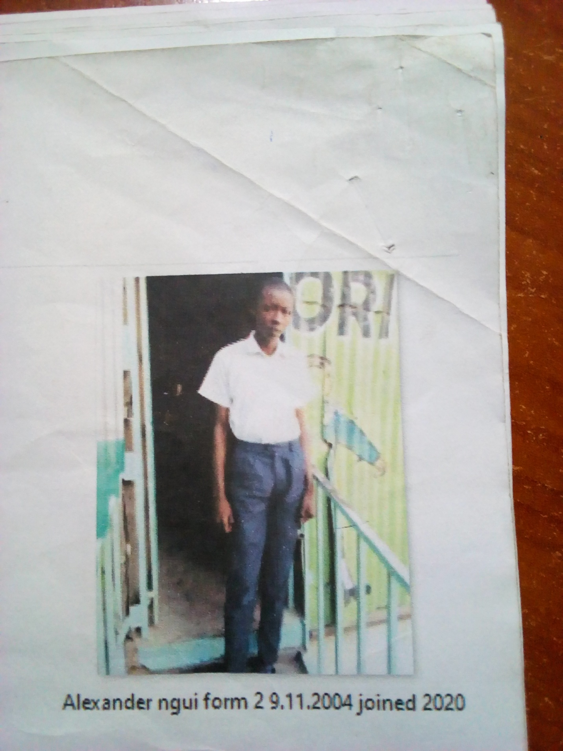

ALEXANDER NGUI FORM 2 BORN 2004 JOINED 2020
Alexander 16 years was enrolled in our school when he was 14 years old. Alexander is a needy boy, picked from the streets of kwa njenga, Alexander looked lost and had lost hope. People who brought him to school said he is a bright boy which has subsequently been verified. He sought help in school and he became accepted in school after the Director was contacted.
Thanks to the Director Mr. Boniface Mangeti who allowed Alexander in school. He is now learning in Glorious at least he has a place he can call home praying that one day God will help our school have good classes, toilets and enough learning materials. Thank you, Mitchell and Brad, for your support have really helped many in Mukuru.

